Foods Name: ___________________________
WVSS Block: ________________

Just Like Grandma’s Bannock

Ingredients
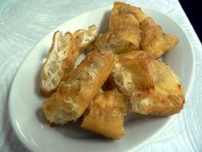

375 ml cups all-purpose flour
125 ml lukewarm water
2 ml salt
2 ml white sugar
15 ml canola oil
15 ml yeast
Canola oil (for frying)

Method:

- In a large bowl, add flour and make a hole in the center. In a separate bowl, combine water, salt, and sugar, 1 tbsp of canola oil, and yeast and stir. Pour into the hole in the flour and mix together by hand to form dough.
- Turn dough onto a lightly floured surface and knead for 10 minutes.
- On a lightly floured surface, roll out dough to a ½ in (1cm) thickness, then cut into 21/2 in (61/2 cm) squares.
- In a large frying pan on high, heat 2 in (5cm) of oil. As soon as the square of dough is dropped into the hot oil, turn it 3 times so that it puffs up evenly.
- Repeat with several pieces at a time and fry until golden brown for 3 minutes on each side until all the dough has been fried.

Makes 4 Bannocks.

Cinnamon & Brown Sugar Bannock:
- For a coffee break or midday treat, lightly spread softened butter over freshly made bannock and sprinkle with a mixture of cinnamon and brown sugar.

Savoury Bannock
Put in cheese, salt, meats, onion, bell peppers inside or on top of your bannock.

