Food Studies 11 Name: ________________________
WVSS Block: _________

Asian Noodle Stir-fry
Ingredients

1 boneless chicken breast
15 mL soy sauce
15 mL sesame oil
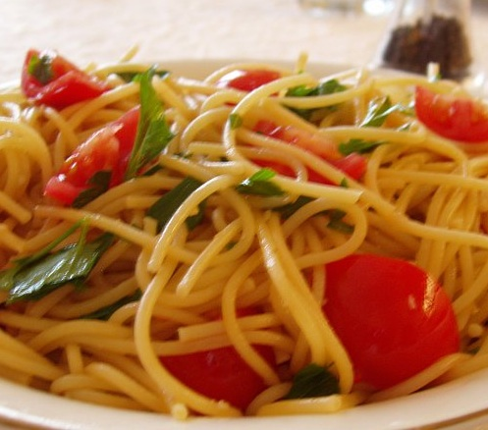
1 mL black ground pepper
2 clove garlic, minced
1 baby bok choy
½ carrot, julienne
15 mL vegetable oil
¼ sweet pepper, strips
½ onion
5 mL ginger root, slices
400g cooked spaghetti
50 mL hoisin sauce
5 mL hot chili pepper (optional)
½ green onion

Method:

- Cut chicken into thin slices. In bowl, toss together chicken, soy sauce, sesame oil, pepper and half of the garlic; marinate for 10 minutes.
- Prepare the vegetables.
- In wok or large skillet, heat 10 mL of the vegetable oil over high heat; stir-fry chicken mixture until browned and juices run clear when chicken is pierced, about 3 minutes. Remove from wok onto a plate
- Add 5 mL oil to the wok. Add bok choy, red pepper, ginger, carrot, onion and remaining garlic; stir-fry until vegetables are tender-crisp, about 2 minutes.
- Add cooked chicken to vegetables.
- Add pasta noodle to the vegetable and chicken mixture. Mix well.
- Add hoisin sauce, hot chili pepper and green onion; toss together until well combined.

Food Studies 11 Name: ________________________
WVSS Block: _________

Pasta Dough
Ingredients:
250 ml flour
2 eggs
2 ml salt
10 ml oil

Method:
1. Put the flour in a heap on a pastry board or in a bowl.
2. Make a well in the center and add the egg, oil and salt.
3. Mix with your hands until the dough can be gathered into a rough ball.
4. Knead the dough on a floured board, working in extra flour if the dough seems sticky.
5. After about 10 minutes, the dough should be smooth, shiny and elastic.
6. Let the dough rest for at least 10 minutes before rolling it.

Pasta Making - Using a Pasta Machine
1. Divide the dough into balls the size of oranges. Work on one at a time. Cover the others.
2. Put the pasta machine rollers at the widest setting.
3. Slightly flatten one ball of dough and flour lightly.
4. Feed the dough through the pasta machine 5-6 times with the rollers at the widest setting.
5. Let the dough fold onto itself as it comes through the rollers.
6. If the dough sticks, dust with flour.
7. Adjust the rollers to the next thinnest setting and feed the dough through the pasta machine 1 time. Do not let the dough fold onto itself this time. Support the dough with your hands as it comes through the rollers - - don’t pull it through, or the dough will shrink.
8. Repeat, adjusting the rollers to the next thinnest and the next thinnest setting. Dust will flour if the dough sticks. If the dough gets too long, you can cut it in half and process half at a time.
9. Repeat until dough has been through the rollers at all settings. Stop at setting 7
10. Lay the dough between two clean cloths and repeat for the remaining balls. Let the pasta dry for 10 minutes.
11. Cut by hand or insert the appropriate blade into the machine and feed dough through the machine one last time.
12. Pasta may be eaten fresh, or dried and stored in glass jars.

