Food Studies 11 Name: _______________________
WVSS Block: _________

Couscous Salad

Ingredients
¼ red peppers, finely diced
¼ red onions, finely diced
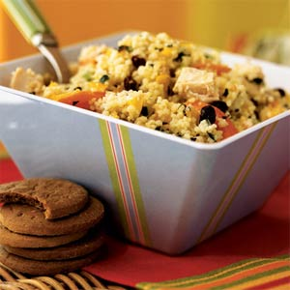
¼ cucumber, finely diced
30 mL raisins (optional)
55 mL couscous or quinoa
85 mL water
125 mL chickpeas
2 roma tomatoes, diced

Dressing
40 mL lemon juice
25 mL olive oil
salt & pepper to taste
1 garlic, minced

Method:
- In a small saucepan, bring water and 1 mL salt to a rolling boil. Turn off heat and add couscous to the saucepan. Let couscous sit for 10 minutes or until no water remains.
- Cut vegetables according to the instructions above. Toss together in a metal bowl.
- Once couscous is done, fluff couscous with a fork. Add to the vegetable mixture.
- Drain and add chickpeas. Combine ingredients well.
- In a small bowl, combine dressing ingredients.
- Add dressing to vegetable mixture and combine well.
- Enjoy.

