Food Studies 12 Name: ______________________
WVSS Block: __________

Samosa
Ingredients

200g ground meat (beef, chicken, pork, turkey, lamb...)
1 small onion
¼ bunch cilantro
1 green chili
10 mL garlic and ginger paste
2 mL turmeric
5mL ground coriander/cumin
20 mL lemon juice
7 mL ground black pepper
2 mL salt

Method:
- Chop onion, chili, and cilantro into small pieces.
- Heat large pan on high and put meat in it. Separate and periodically stir the meat until it is cooked or no longer pink and until the water which comes out form the meat has dried.
- Add garlic and ginger paste and lemon to the meat.
- Stir and let it cook for approximately 2 minutes.
- Add salt, pepper, coriander/cumin and turmeric to the mixture. Stir and let it cook for approximately 5 minutes.
- Turn the heat to medium and add onions, chilies and cilantro.
- Stir and let it sit for approximately 1 minute. Repeat until onions are soft.
- Put the mixture in a bowl and stick it in the freezer for 5 minutes.
- While the mixture is cooking, take a small pan and fill it half way with oil.
- Heat the oil on high. When it is hot, lower the heat to the lowest number and wait for the oil to cool.
- Fill mixture into the wrap. The instructions on how to fold samosas are below.
- Fry 2 samosa’s at a time on low until they are golden brown.
- Place samosa’s on a plate with paper towel on it.
- Wait for it to cool and eat with lemon.

Food Studies 12 Name: ______________________
WVSS Block: __________

Pastry for Samosa
Ingredients:
250 mL all purpose flour
1 mL salt
5 mL lemon juice
125 mL water

Method:
- Combine flour, salt and lemon juice in a bowl.
- Add water, a little at a time until you have fairly firm dough. Knead well. Divide dough into 2 equal balls.
- Roll out ball into a rectangle about 0.3 cm thick. Meanwhile, placing the other under a damp cloth.
- Using a pizza cutter, cut 7cm thick strips. (4-5 short strips)
- Fold samosa according to diagram.
- Repeat steps 3-7 with the remaining dough.

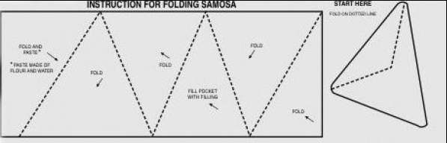

http://www.youtube.com/watch?v=kWjg3zdEx3w

